Housing Information for Wheeling University

How to complete the housing application: (Reference page two and three below)

Building preferences:

This year, first year female students live in Sara Tracy Hall and first year male students live in Campion or McHugh Hall. These spaces will be offered based on when housing applications are completed/submitted. The Office of Residence Life’s goal is to have an accommodating environment for our first year students. We house our first year students together to be able to have targeted programming towards their needs as they transition from home to their new home here at Wheeling University. You can visit the link below to understand the differences between these residence halls.

https://wheeling.edu/student-life/living-on-campus/residence-halls/

Living Accommodations:

For accommodations concerning any living situation please contact the Office of Residence Life. All requests for a medically documented accommodation must be submitted and approved. Additional information can be found by following the link below:

https://wheeling.edu/student-life/student-support-services/disability-services/housing-requests/

This process can take multiple weeks, so please be timely with any requests.

If a student believes additional consideration may be needed for their room assignment, please contact the Office of Residence Life at 304-243-2175 or reslife@wheeling.edu

Living Off Campus:

Complete the Off Campus Housing Request Form. This form is available upon request to the Office of Student Services as studentlife@wheeling.edu.

COMPLETING YOUR WHEELING UNIVERSITY HOUSING APPLICATION

- Go to wju.erezlife.com
- Type in University E-Mail Address
- Click “Activate Account”
- Type in your Wheeling University email and your student ID (include the leading “0” – example “0123456”
- Click “Activate Account”
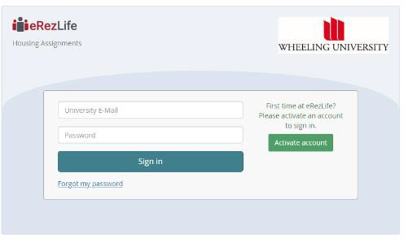

- An automatically generated e-mail will be sent to your University e-mail account
- Open automatically generated e-mail and click the provided link
- Follow the instructions to generate and confirm your account password
- Click “Reset” You will then automatically be signed into your User Account
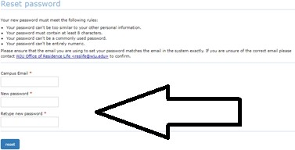

- Click “Finish Applicant Profile” and then complete the required fields (e.g. Insurance Provider, Emergency Contact Information, and any Medications/Allergies).
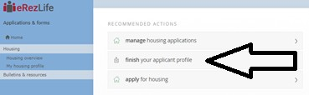

- Click “Save”
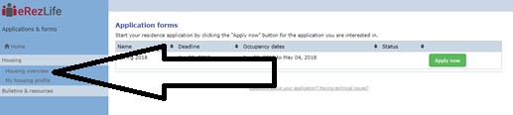
- Click “Housing Overview” along the left side

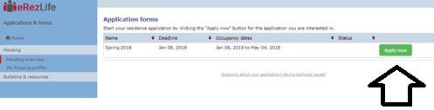
- Click “Apply Now” Be sure you’re applying for the semester in which you will begin living on campus (i.e. Spring 2020, Fall 2020)
- Complete the Required Fields on the Application Form. After completing, click “Continue to Confirm application” in the bottom right hand corner.
- Click on “terms & conditions file” to review the Housing Contract.
- Check the two (boxes) confirming you have read the Housing Contract and that you are providing accurate information.
- Click “Submit Application”
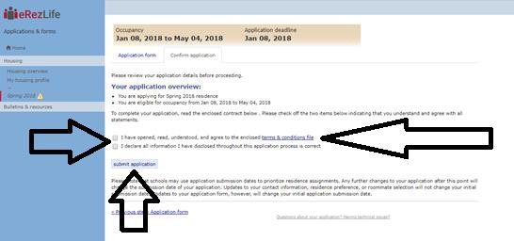
- You have now completed the application! The Office of Residence Life will communicate additional information to you through your University e-mail account or by phone as needed.

